Experiment - 08

Student Name: ADITYA SHARMA UID: 24BAI70379

Branch: CSE - AIML Section/Group: 24AIT_KRG-1_A

Semester: 5 Date of Performance: 13/9/26
Subject Name: ADBMS Subject Code: 24CSP-310

(A)
A company maintains customer information, product information, and sales order information in three separate tables: customer_master, product_catalog, and sales_orders.

The company wants to provide an order report to an external client. The report must contain the Order ID, Order Date, Customer Name, Product Name, and Final Amount.
For every order, first calculate the Gross Amount using:
Gross Amount = Unit Price × Quantity Then calculate the Discount Amount using:
Discount Amount = Gross Amount × Discount Percentage / 100 Finally, calculate the Final Amount using:
Final Amount = Gross Amount − Discount Amount
Create a complex view using the three tables to generate this report. The view should expose only the required five columns and should not expose the customer's phone/email, product brand/unit price, or the order's quantity/discount percentage. The company also wants to provide access to an external client. Create a PostgreSQL user named client_user and give this user only SELECT permission on the view. The client must not have direct access to the three original tables and must not be allowed to modify the view data.

Output:

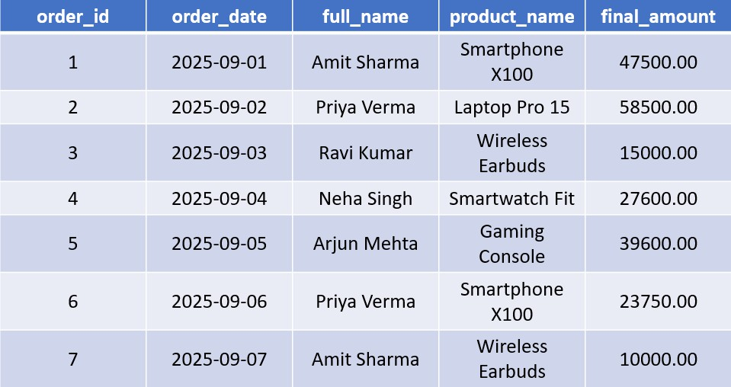

Solution:
CREATE OR REPLACE VIEW vW_FINAL_AMOUNT_CALCULATION AS
SELECT O.ORDER_ID, O.ORDER_DATE, C.FULL_NAME, P.PRODUCT_NAME,
ROUND((P.UNIT_PRICE*O.QUANTITY - P.UNIT_PRICE*O.QUANTITY*O.DISCOUNT_PERCENT/100.0), 2) AS FINAL_AMOUNT
FROM SALES_ORDERS AS O JOIN PRODUCT_CATALOG AS P
ON O.PRODUCT_ID = P.PRODUCT_ID JOIN CUSTOMER_MASTER AS C
ON O.CUSTOMER_ID=C.CUSTOMER_ID
SELECT * FROM vW_FINAL_AMOUNT_CALCULATION; CREATE USER CLIENT_1234
PASSWORD '12345';

GRANT SELECT ON vW_FINAL_AMOUNT_CALCULATION TO CLIENT_1234

(B)
An e-commerce company wants to regularly analyze the performance of its product categories.
The company stores product, category, customer, and order information in separate tables. To generate the category performance report, the database needs to perform multiple JOINs, GROUP BY, aggregate functions, DISTINCT counting, calculated values, and CASE statements.
Since the same report is generated frequently, executing the complete analytical query every time can increase database workload.
Create a PostgreSQL Materialized View named: mv_category_sales
Also demonstrate that when new order data is inserted, the Materialized View does not automatically reflect the change and must be refreshed.
Finally, use EXPLAIN ANALYZE to compare the performance of the original analytical query with the Materialized View query.

Output:
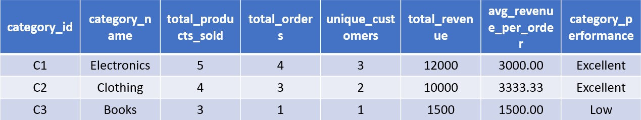

Solution:
EXPLAIN ANALYZE
SELECT CAT.CATEGORY_ID, CAT.CATEGORY_NAME, SUM(O.QUANTITY) AS TOTAL_PRODUCTS_SOLD, COUNT(DISTINCT O.ORDER_ID) AS TOTAL_ORDERS, COUNT(DISTINCT O.CUSTOMER_ID) AS UNIQUE_CUSTOMERS, SUM(O.QUANTITY*O.UNIT_PRICE) AS TOTAL_REVENUE, ROUND(SUM(O.QUANTITY*O.UNIT_PRICE)/COUNT(DISTINCT
O.ORDER_ID), 2) AS AVERAGE_REVENUE_PER_ORDER, CASE
WHEN SUM(O.QUANTITY*O.UNIT_PRICE) >= 10000 THEN 'EXCELLENT'
WHEN SUM(O.QUANTITY*O.UNIT_PRICE) >= 6000 THEN
'GOOD'
WHEN SUM(O.QUANTITY*O.UNIT_PRICE) >=3000 THEN
'AVERAGE'
ELSE 'LOW'
END AS CATEGORY_PERFORMANCE FROM ORDER_DETAILS AS O
JOIN PRODUCT_MASTER AS P
ON O.PRODUCT_ID=P.PRODUCT_ID JOIN CATEGORY_MASTER AS CAT
ON P.CATEGORY_ID=CAT.CATEGORY_ID
GROUP BY CAT.CATEGORY_ID, CAT.CATEGORY_NAME

CREATE MATERIALIZED VIEW MV_CATEGORY_SALES AS
SELECT CAT.CATEGORY_ID, CAT.CATEGORY_NAME, SUM(O.QUANTITY) AS TOTAL_PRODUCTS_SOLD, COUNT(DISTINCT O.ORDER_ID) AS TOTAL_ORDERS, COUNT(DISTINCT O.CUSTOMER_ID) AS UNIQUE_CUSTOMERS, SUM(O.QUANTITY*O.UNIT_PRICE) AS TOTAL_REVENUE, ROUND(SUM(O.QUANTITY*O.UNIT_PRICE)/COUNT(DISTINCT
O.ORDER_ID), 2) AS AVERAGE_REVENUE_PER_ORDER, CASE
WHEN SUM(O.QUANTITY*O.UNIT_PRICE) >= 10000 THEN 'EXCELLENT'
WHEN SUM(O.QUANTITY*O.UNIT_PRICE) >= 6000 THEN
'GOOD'
WHEN SUM(O.QUANTITY*O.UNIT_PRICE) >=3000 THEN
'AVERAGE'
ELSE 'LOW'
END AS CATEGORY_PERFORMANCE FROM ORDER_DETAILS AS O
JOIN PRODUCT_MASTER AS P
ON O.PRODUCT_ID=P.PRODUCT_ID JOIN CATEGORY_MASTER AS CAT
ON P.CATEGORY_ID=CAT.CATEGORY_ID
GROUP BY CAT.CATEGORY_ID, CAT.CATEGORY_NAME

EXPLAIN ANALYZE
SELECT * FROM MV_CATEGORY_SALES
REFRESH MATERIALIZED VIEW MV_CATEGORY_SALES

